**How to Add Imagine Learning Button to Canvas Page**

1. Go to your Canvas front page

1. Click "Edit" on the top right corner



1. Click Insert > Image > Course Images

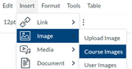

1. Choose the Imagine Learning image



1. After the image is on your front page, click on the image, click Insert > Link > External Links

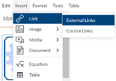

1. Type "app.imaginelearning.com" in the blank space

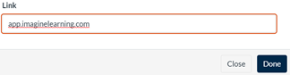

1. Click "Done"   
   

1. Click "Save" at the bottom of the page.

